Modification List
Description:
Firstly, we go through the basic background of Nicaragua. Then we add reasoning analyses on the unemployment rate, Balance of payment components and revise the graph of inflation differentials. We found that Nicaragua faced the internal political shocks and also external economics instability. Lastly, we propose that Nicaragua should diversify its export market and purify its business environment.
Details of modifications:
1. Introduction
Nicaragua is the country in the Central America. Its main industries are focused on light manufacturing, services, and agriculture. It is still considered as one of poor countries in Latin America. Its potential is now limited by lack of human capital, exports focused on primary and light industries, and unstable business environment and political issue.
However, it is possible for Nicaragua economy to overcome the crisis and grow. With proper policy, and investment, it can recover the potential before 2018. To find out Nicaragua’s real potential and economic prospect, we will view several figures and charts and regarding economy during past years.
2. Nicaragua is generally a met borrower.
3. Overall, in the period spanning from 2013 to 2021, Nicaragua's balance of goods and services (BGS) movements remained closely tied to its current account, indicating relative stability in the country's primary income outflows (BPI). In 2018, there were a series protest activities and socio-political crisis occurred, lowering the employment rate as well as purchasing demand, finally leading to lower import demand. This lower import demand resulted in the current account surplus. Also, Maquilas and Coffee are two important export components of Nicaragua’s trade account. For Maquilas, including textile, chemistry, food factory and manufacturing and so on, were gradually transferred to South America, and have become the main supplier to U.S market.
4. Nicaragua is a net oil importer ranking, the rise of oil prices was one of the reasons for increasing goods and services deficits.
5. The last graph has been revised.
6. Conclusion: In conclusion, Nicaragua's economic journey reflects resilience amid challenges. After analysis, we suggest Nicaragua to reduce dependency on a few export markets by diversifying export destinations, develop its agriculture as well as promote its industrialization process. Also, the stable and transparent business environment may help Nicaragua attract foreign investment. Overall, Nicaragua's economy is in transition and need more devotion to stabilize its economy and politics.

Nicaragua Country Report Revised Version
Group 9
Dayoung Kim
Yijie Yu
2024/03/25

Table of contents
Cover page 1
Introduction 2
Part 2 2
Economic growth; Unemployment; Inflation; Public debt; Government deficit; International reserves. 2
Part 3 3
Current account; Balance of goods and services; Balance of primary income; Foreign direct investment inflows; International currency reserves 3
Part 4 4
Evolution of the nominal and real exchange rates 4
Part 5 4
Inflation differential and spot dollar exchange rate 4
Conclusion 4
Reference 5

*Note: The revised parts are highlighted.

Introduction
Nicaragua is the country in the Central America. Its main industries are focused on light manufacturing, services, and agriculture. It is still considered as one of poor countries in Latin America. Its potential is now limited by lack of human capital, exports focused on primary and light industries, and unstable business environment and political issue.
However, it is possible for Nicaragua economy to overcome the crisis and grow. With proper policy, and investment, it can recover the potential before 2018. To find out Nicaragua’s real potential and economic prospect, we will view several figures and charts and regarding economy during past years.

Part 1.
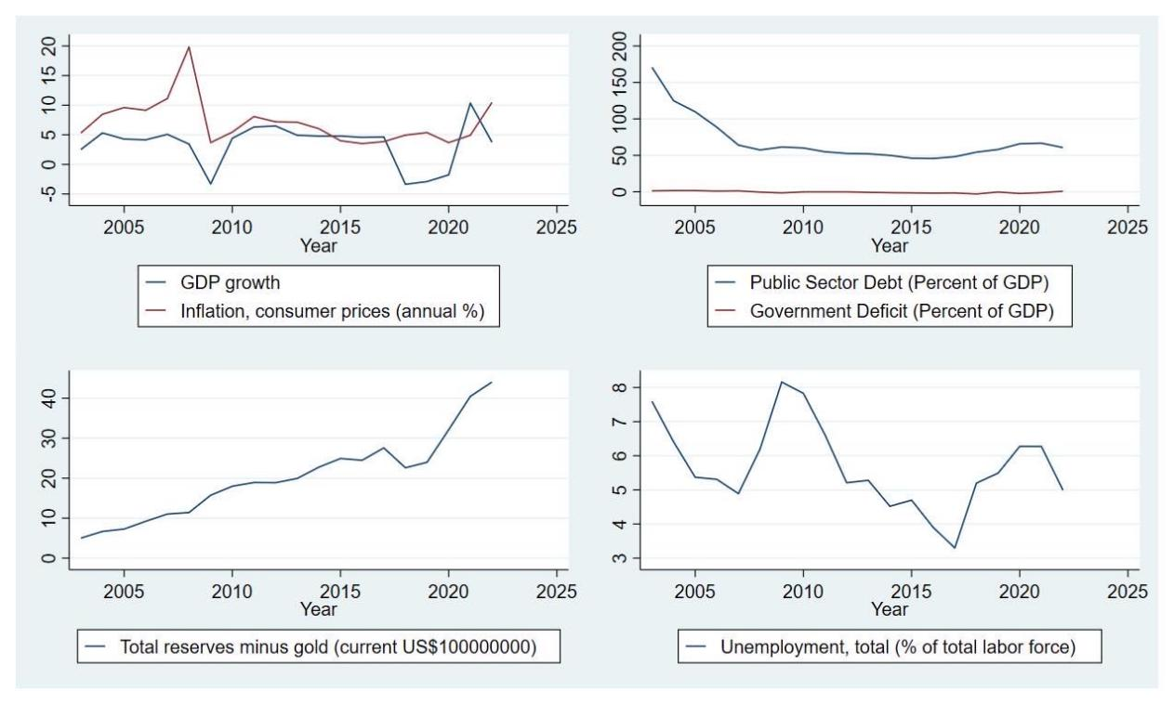
Graph 1 (2003~2022), Source: World Bank Data & IMF
Nicaragua’s GDP growth (Economic growth) was minus in 2009 but jumped to positive figures. It dropped largely in the period of 2018~2020. In contrast, inflation rate surged in same period. It was due to changes of government policy. In 2018, There was a collapse of democracy in the country at the time.
Unemployment was over 8 percent in 2009, which was the highest during the last 20 years, and over 6% in 2018~2020. It was due to the Great recession and domestic political issue respectively. The period corresponds to when GDP growth was minus. In 2022, Nicaragua’s labor market stabilized, and the unemployment rate dropped.
Public debt had declined from 170.98 percent in 2003 to 64.07 percent in 2007. Since then, it remained around 50 percent. In 2018~2019, it increased but dropped in 2022. In the case of Government deficit (Government net lending/borrowing), there was no fluctuation during the last 20 years.
Total reserves without gold (Current US$100000000) are continuously growing except in the period of 2018~2019. It dropped during two years but recovered in 2020.

Part 2.
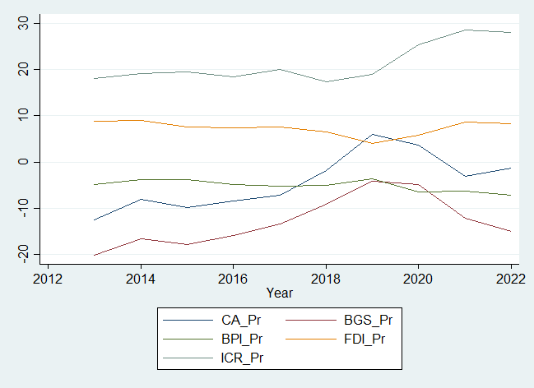
Graph 2 (2013~2022), World Bank Data Note: Pr means percentage
The current account (CA) of Nicaragua was negative from 2013 to 2018, but the deficit was narrowing. It experienced a huge jump in 2019, peaking at 2019 approximately 5.9% of GDP and enjoying a surplus in 2019 and 2020. However, it quickly dropped to negative in 2021 and 2022. Nicaragua is generally a met borrower.
Overall, in the period spanning from 2013 to 2021, Nicaragua's balance of goods and services (BGS) movements remained closely tied to its current account, indicating relative stability in the country's primary income outflows (BPI). In 2018, there were a series protest activities and socio-political crisis occurred, lowering the employment rate as well as purchasing demand, finally leading to lower import demand. This lower import demand resulted in the current account surplus. Also, Maquilas and Coffee are two important export components of Nicaragua’s trade account. For Maquilas, including textile, chemistry, food factory and manufacturing and so on, were gradually transferred to South America, and have become the main supplier to U.S market.
However, in 2022, the balance of goods and services saw a drop in the proportion of GDP while the current account saw an increase. Nicaragua is a net oil importer ranking, the rise of oil prices was one of the reasons for increasing goods and services deficits.
The foreign direct investment proportion ranged from 3% to 9% of GDP. 2019 had a 3.961% of GDP in foreign direct investment and 2014 peaked at 9.064%. Sustained FDI supported a continued accumulation of gross international reserves.
Over the past few years, the international currency reserves (which includes gold) have shown a steady but fluctuating trend. However, since the onset of the pandemic in 2021, there has been a significant increase in these reserves, which have risen from approximately 20% to 30% of the GDP. This increase can be attributed to the measures taken by various countries to mitigate the impact of the pandemic on their economic stability and offset the volatility of current account deficits.

Part 3.
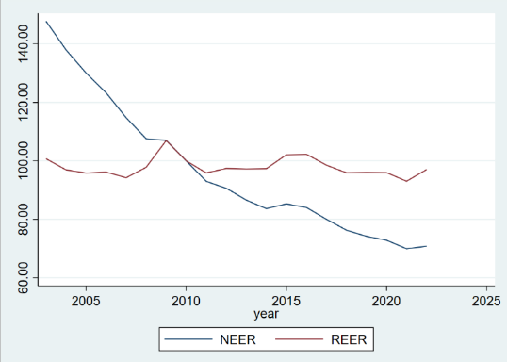
Graph 3 (2003~2022), IMF: International Financial Statistics
The real effective exchange rate (REER) between Nicaragua’s currency and the US dollar shows a different evolution from the nominal effective exchange rate (NEER). It is due to each country’s price level. As Nicaragua’s price level increased, its currency power decreased. Compared to February 2020, from the perspective of REER, the value of Nicaragua Currency has very little bit depreciated in 2022.

Part 4.
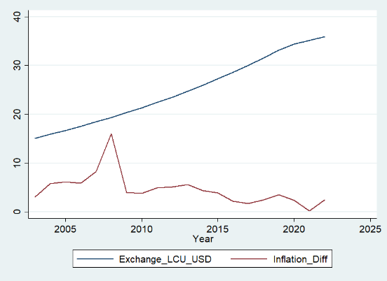
Graph 4 (2003~2022), World Bank Data
Note: CPI means this inflation rates are calculated based on consumption
The exchange rate between the córdoba and the dollar consistently increases.
The inflation of Nicaragua exceeds inflation in the US from 2013 to 2022. According to the purchasing power parity (PPP), the value of the córdoba decreases relative to the dollar, leading to the depreciation of the córdoba against the dollar in the foreign exchange market. What we can conclude are that the relation between spot dollar exchange rate and inflation differential follows the purchasing power parity—the larger difference between the córdoba and US dollar, the higher the exchange rate, the less valuable of córdoba.

Conclusion
In conclusion, Nicaragua's economic journey reflects resilience amid challenges. After analysis, we suggest Nicaragua to reduce dependency on a few export markets by diversifying export destinations, develop its agriculture as well as promote its industrialization process. Also, the stable and transparent business environment may help Nicaragua attract foreign investment. Overall, Nicaragua's economy is in transition and need more devotion to stabilize its economy and politics.

Reference:
The World Bank. (n.d). The World Bank IBRD·IDA data. Retrieved March 17, 2024, from https://data.worldbank.org/indicator/NY.GDP.MKTP.CD?locations=NI (GDP)
The World Bank. (n.d). The World Bank IBRD·IDA data. Retrieved April 15, 2024, from https://data.worldbank.org/indicator/BN.CAB.XOKA.CD?locations=NI (Current account)
The World Bank. (n.d). The World Bank IBRD·IDA data. Retrieved April 15, 2024, from https://data.worldbank.org/indicator/NE.IMP.GNFS.CD?locations=NI (Imports of goods and services)
The World Bank. (n.d). The World Bank IBRD·IDA data. Retrieved April 15, 2024, from https://data.worldbank.org/indicator/NE.IMP.GNFS.CD?locations=NI (Exports of goods and services)
The World Bank. (n.d). The World Bank IBRD·IDA data. Retrieved April 15, 2024, from https://data.worldbank.org/indicator/BM.GSR.FCTY.CD?locations=NI (Balances of primary income)
The World Bank. (n.d). The World Bank IBRD·IDA data. Retrieved April 15, 2024, from https://data.worldbank.org/indicator/BX.KLT.DINV.WD.GD.ZS (Foreign direct investment inflows)
The World Bank. (n.d). The World Bank IBRD·IDA data. Retrieved April 15, 2024, from https://data.worldbank.org/indicator/PA.NUS.FCRF?locations=NI (Exchange rate, LCU per USD)
The World Bank. (n.d). The World Bank IBRD·IDA data. Retrieved April 15, 2024, from https://data.worldbank.org/indicator/FP.CPI.TOTL.ZG?locations=NI (Inflation rate, consumer prices, Nicaragua)
The World Bank. (n.d). The World Bank IBRD·IDA data. Retrieved April 15, 2024, from https://data.worldbank.org/indicator/FP.CPI.TOTL.ZG?locations=NI (Inflation rate, consumer prices, United States)
International Monetary Fund. (n.d). IMF DATAMAPPER. DATASETS. GLOBAL DEBT DATABASE. Public Sector Debt. Retrieved March 22, 2024, from https://www.imf.org/external/datamapper/PS_DEBT_GDP@GDD/NIC
International Monetary Fund. (n.d). IMF DATAMAPPER. DATASETS. WORLD ECONOMIC OUTLOOK (OCTOBER 2023). General Government Net Lending/Borrowing. Retrieved March 22, 2024, from https://www.imf.org/external/datamapper/GGXCNL_NGDP@WEO/NIC
International Monetary Fund. (n.d). IMF DATA ACCESS TO MACROECONOMIC & FINANCIAL DATA. International Financial Statistics (IFS). Data By Country. Exchange Rates incl. Effective Ex. Rates. Nicaragua Annual Data, Retrieved March 21, 2024, from https://data.imf.org/regular.aspx?key=61545850
The World Bank. (n.d). The World Bank IBRD·IDA| Data. GDP growth (annual %) – Nicaragua. Retrieved March 22, 2024, from GDP growth (annual %) - Nicaragua | Data (worldbank.org)
The World Bank. (n.d). The World Bank IBRD·IDA| Data. Inflation, consumer price (annual %)-Nicaragua. Retrieved March 22, 2024, from Inflation, consumer prices (annual %) - Nicaragua | Data (worldbank.org)
The World Bank. (n.d). The World Bank IBRD·IDA| Data. Total reserves minus gold (current US$) -Nicaragua. Retrieved March 22, 2024, from Total reserves minus gold (current US$) - Nicaragua | Data (worldbank.org)
The World Bank. (n.d). The World Bank IBRD·IDA| Data. Unemployment, total(% of total labor force)(modeled ILO estimates)-Nicaragua. Retrieved March 22, 2024, from Unemployment, total (% of total labor force) (modeled ILO estimate) - Nicaragua | Data (worldbank.org)
International Money Fund. (2024). "Nicaragua: 2023 Article IV Consultation-Press Release; and Staff Report". Retrieved March 19, 2024, from https://www.imf.org/en/Publications/CR/Issues/2024/01/19/Nicaragua-2023-Article-IV-Consultation-Press-Release-and-Staff-Report-543914
The World Bank. (n.d). The World Bank IBRD·IDA. Retrieved Oct 04, 2023, from https://www.worldbank.org/en/country/nicaragua/overview#2
The World Bank. (n.d). The World Bank IBRD·IDA. Retrieved Oct 04, 2023, from https://www.worldbank.org/en/country/nicaragua/overview#2

The World Bank Nicaragua Overview, https://www.worldbank.org/en/country/nicaragua/overview#1
The World Bank Nicaragua Overview, https://www.worldbank.org/en/country/nicaragua/overview#1
Nicaragua: 2019 Article IV Consultation-Press Release; Staff Report; and Statement by the Executive Director for Nicaragua, https://www.imf.org/en/Publications/CR/Issues/2020/02/27/Nicaragua-2019-Article-IV-Consultation-Press-Release-Staff-Report-and-Statement-by-the-49129
Nicaragua: 2023 Article IV Consultation-Press Release; and Staff Report, https://www.imf.org/en/Publications/CR/Issues/2024/01/19/Nicaragua-2023-Article-IV-Consultation-Press-Release-and-Staff-Report-543914
The World Bank Nicaragua Overview, https://www.worldbank.org/en/country/nicaragua/overview#1
The World Bank Nicaragua Overview, https://www.worldbank.org/en/country/nicaragua/overview#1
International trade administration. Nicaragua-Country commercial Guide https://www.trade.gov/country-commercial-guides/nicaragua-market-overview
Nicaragua: 2019 Article IV Consultation-Press Release; Staff Report; and Statement by the Executive Director for Nicaragua, https://www.imf.org/en/Publications/CR/Issues/2020/02/27/Nicaragua-2019-Article-IV-Consultation-Press-Release-Staff-Report-and-Statement-by-the-49129
Nicaragua: 2023 Article IV Consultation-Press Release; and Staff Report, https://www.imf.org/en/Publications/CR/Issues/2024/01/19/Nicaragua-2023-Article-IV-Consultation-Press-Release-and-Staff-Report-543914

